Building a multi-table relational database in SQL

You are now going to build a new database in mySQL, using commands from PHP.

Last lesson you generated a table using the CREATE command in SQL, then you populated it with an html form.

Do the same, but this time we want a database with more than one table, (you can create the tables separately and use separate forms to populate them.)

Make sure that there is a primary key in each table.

The tables you need to build are: Customers, Accounts, Products.

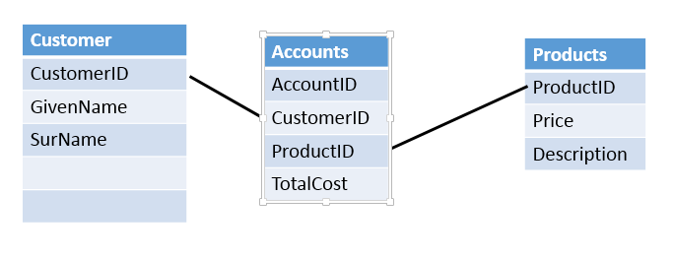

When you populate the tables, make sure a customer number appears in accounts, and product name or number appears in accounts.

Populate each table with 20 records.

Build a php page that contains 3 tables that contain a table header and that display the data from the three tables.

Build another php page that contains a table with the ability to display fields from both customers and accounts.

Zip your files together for upload.